Diego André Mazariegos Barrientos Carnet:202003975

Procedimiento Método del árbol

Paso 1) expresión regular.

**Expresión regular 2.0**

Le = [A_Z, a_z]

Palabra = Le+

Di = [0_9]

Digito = Di+

**Expresión regular**

TITULO**|**=**|**”Palabra”**|**ANCHO**|**ALTO**|**Digito**|**;**|**FILAS**|**COLUMNAS**|**CELDAS**|**{**|**}**|**[**|**]**|**,**|**FALSE**|**TRUE**|**(#(D**|**L){6})**|**FILTROS**|**MIRRORX**|**MIRRORY**|**DOUBLEMIRROR**|**@@@@

Paso 1.1) Agregar al final de la expresión regular el $.

**Expresión regular**

**(**TITULO**|**=**|**”Palabra”**|**ANCHO**|**ALTO**|**Digito**|**;**|**FILAS**|**COLUMNAS**|**CELDAS**|**{**|**}**|**[**|**]**|**,**|**FALSE**|**TRUE**|**(#(D**|**L){6})**|**FILTROS**|**MIRRORX**|**MIRRORY**|**DOUBLEMIRROR**|**@@@@**)$**

Paso 2) Formar Árbol de sintaxis.

Para la realización del árbol se utilizó la plataforma draw.io el cual es un editor de diagramas online gratis.

Para este paso se determinó para cada nodo lo siguiente.

* Si era Anulable o no Anulable marcando con un V si es Anulable y F si no lo es.
* Se determinó para cada nodo sus siguientes.
* Se determinó para cada nodo sus últimos.

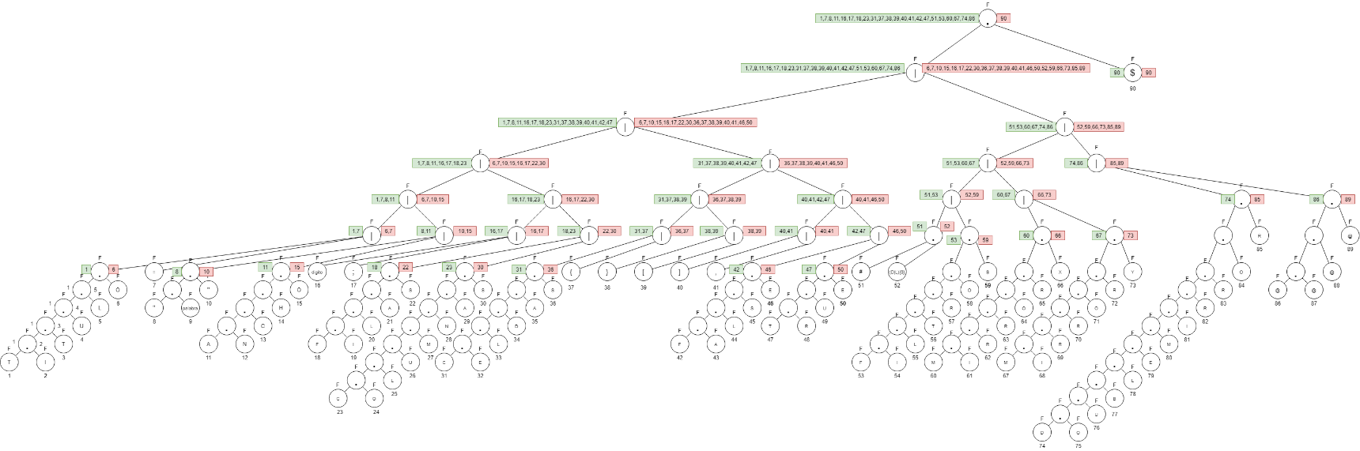

*Figura 1. Diagrama del árbol binario con todos los procedimientos realizados.*

Fuente: elaboración propia, 2021.

Paso 2.1) Calcular tabla de siguientes.

|  |  |  |
| --- | --- | --- |
| **CALCULANDO SIGUIENTES** | | |
|  |  |  |
| **VALOR** | **HOJA** | **SIGUIENTES** |
| T | 1 | 2 |
| I | 2 | 3 |
| T | 3 | 4 |
| U | 4 | 5 |
| L | 5 | 6 |
| O | 6 | 90 |
| = | 7 | 90 |
| " | 8 | 9 |
| palabra | 9 | 10 |
| " | 10 | 90 |
| A | 11 | 12 |
| N | 12 | 13 |
| C | 13 | 14 |
| H | 14 | 15 |
| O | 15 | 90 |
| digito | 16 | 90 |
| ; | 17 | 90 |
| F | 18 | 19 |
| I | 19 | 20 |
| L | 20 | 21 |
| A | 21 | 22 |
| S | 22 | 90 |
| C | 23 | 24 |
| O | 24 | 25 |
| L | 25 | 26 |
| U | 26 | 27 |
| M | 27 | 28 |
| N | 28 | 29 |
| A | 29 | 30 |
| S | 30 | 90 |
| C | 31 | 32 |
| E | 32 | 33 |
| L | 33 | 34 |
| D | 34 | 35 |
| A | 35 | 36 |
| S | 36 | 90 |
| { | 37 | 90 |
| } | 38 | 90 |
| [ | 39 | 90 |
| ] | 40 | 90 |
| , | 41 | 90 |
| F | 42 | 43 |
| A | 43 | 44 |
| L | 44 | 45 |
| S | 45 | 46 |
| E | 46 | 90 |
| T | 47 | 48 |
| R | 48 | 49 |
| U | 49 | 50 |
| E | 50 | 90 |
| # | 51 | 52 |
| (D|L){6} | 52 | 90 |
| F | 53 | 54 |
| I | 54 | 55 |
| L | 55 | 56 |
| T | 56 | 57 |
| R | 57 | 58 |
| O | 58 | 59 |
| S | 59 | 90 |
| M | 60 | 61 |
| I | 61 | 62 |
| R | 62 | 63 |
| R | 63 | 64 |
| O | 64 | 65 |
| R | 65 | 66 |
| X | 66 | 90 |
| M | 67 | 68 |
| I | 68 | 69 |
| R | 69 | 70 |
| R | 70 | 71 |
| O | 71 | 72 |
| R | 72 | 73 |
| Y | 73 | 90 |
| D | 74 | 75 |
| O | 75 | 76 |
| U | 76 | 77 |
| B | 77 | 78 |
| L | 78 | 79 |
| E | 79 | 80 |
| M | 80 | 81 |
| I | 81 | 82 |
| R | 82 | 83 |
| R | 83 | 84 |
| O | 84 | 85 |
| R | 85 | 90 |
| @ | 86 | 87 |
| @ | 87 | 88 |
| @ | 88 | 89 |
| @ | 89 | 90 |
| $ | 90 | --- |

Paso 2.2) Construyendo tabla de transiciones.

|  |  |  |  |  |  |  |  |  |
| --- | --- | --- | --- | --- | --- | --- | --- | --- |
|  |  | **CONSTRUYENDO TABLA DE TRANSICIONES** | | |  |  |  |  |
|  |  |  |  |  |  |  |  |  |
|  |  | **ESTADO** | **VALORES** | **SIGUIENTES** |  |  |  |  |
|  | Inicio/ aceptación | S0 | |  | | --- | | 1,7,8,11,16,17,18,23,31,37,38,39,40,41,42,47,51,53,60,67,74,86 | |  |  |  |  |  |
|  |  |  |  |  |  |  |  |  |
|  |  |  |  |  |  |  |  |  |
|  |  |  |  |  |  |  |  |  |
|  |  |  |  |  |  |  |  |  |
|  |  |  |  |  |  |  |  |  |
|  |  |  |  |  |  |  |  |  |
|  |  | S1 | 2,48 |  |  |  |  |  |
|  |  |  |  |  |  |  |  |
|  |  |  |  |  |  |  |  |
|  |  |  |  |  |  |  |  |  |
|  | aceptación | S2 | 90 | --- |  |  |  |  |
|  |  | S3 | 9 | 9(palabra){10}=S13 |  |  |  |  |
|  |  |  |  |  |  |  |  |  |
|  |  |  | |  | | --- | |  | |  |  |  |  |  |
|  |  | S4 | 12 |  |  |  |  |  |
|  |  | S5 | 19,43,54 |  |  |  |  |  |
|  |  |  |  |  |  |  |  |  |
|  |  |  |  |  |  |  |  |  |
|  |  | S6 | 24,32 |  |  |  |  |  |
|  |  |  |  |  |  |  |  |  |
|  |  | S7 | 52 |  |  |  |  |  |
|  |  |  |  |  |  |  |  |  |
|  |  | S8 | 61,68 |  |  |  |  |  |
|  |  | S9 | 75 |  |  |  |  |  |
|  |  | S10 | 87 |  |  |  |  |  |
|  |  | S11 | 3 |  |  |  |  |  |
|  |  | S12 | 49 | 49(U){50}=S23 |  |  |  |  |
|  |  | S13 | 10 | 10("){90}=S2 |  |  |  |  |
|  |  | S14 | 13 | 13(C){14}=S24 |  |  |  |  |
|  |  | S15 | 20,55 | 20,55(L){21,56}=S25 |  |  |  |  |
|  |  | S16 | 44 | 44(L){45}=S26 |  |  |  |  |
|  |  | S17 | 25 | 25(L){26}=S27 |  |  |  |  |
|  |  | S18 | 33 | 33(L){34}=S28 |  |  |  |  |
|  |  | S19 | 62,69 | 62(R){63,70}=S29 |  |  |  |  |
|  |  | S20 | 76 | 76(U){77}=S30 |  |  |  |  |
|  |  | S21 | 88 | 88(@){89}=S31 |  |  |  |  |
|  |  | S22 | 4 | 4(U){5}=S32 |  |  |  |  |
|  |  | S23 | 50 | 50(E){90}=S2 |  |  |  |  |
|  |  | S24 | 14 | 14(H){15}=S33 |  |  |  |  |
|  |  | S25 | 21,56 | 21(A){22}=S34 |  |  |  |  |
|  |  |  |  | 56(T){57}=S35 |  |  |  |  |
|  |  | S26 | 45 | 45(S){46}=S36 |  |  |  |  |
|  |  | S27 | 26 | 26(U){27}=S37 |  |  |  |  |
|  |  | S28 | 34 | 34(D){35}=S38 |  |  |  |  |
|  |  | S29 | 63,70 | 63,70(R){64,71}=S39 |  |  |  |  |
|  |  | S30 | 77 | 77(B){78}=S40 |  |  |  |  |
|  |  | S31 | 89 | 89(@){90}=S2 |  |  |  |  |
|  |  | S32 | 5 | 5(L){6}=S41 |  |  |  |  |
|  |  | S33 | 15 | 15(O){90}=S2 |  |  |  |  |
|  |  | S34 | 22 | 22(S){90}=S2 |  |  |  |  |
|  |  | S35 | 57 | 57(R){58}=S42 |  |  |  |  |
|  |  | S36 | 46 | 46(E){90}=S2 |  |  |  |  |
|  |  | S37 | 27 | 27(M){28}=S43 |  |  |  |  |
|  |  | S38 | 35 | 35(A){36}=S44 |  |  |  |  |
|  |  | S39 | 64,71 | 64,71(O){65,72}=S45 |  |  |  |  |
|  |  | S40 | 78 | 78(L){79}=S46 |  |  |  |  |
|  |  | S41 | 6 | 6(O){90}=S2 |  |  |  |  |
|  |  | S42 | 58 | 58(0){59}=S47 |  |  |  |  |
|  |  | S43 | 28 | 28(N){29}=S48 |  |  |  |  |
|  |  | S44 | 36 | 36(S){90}=S2 |  |  |  |  |
|  |  | S45 | 65,72 | 65,72(R){66,73}=S49 |  |  |  |  |
|  |  | S46 | 79 | 79(E){80}=S50 |  |  |  |  |
|  |  | S47 | 59 | 59(S){90}=S2 |  |  |  |  |
|  |  | S48 | 29 | 29(A){30}=S51 |  |  |  |  |
|  |  | S49 | 66,73 | 66(X){90}=S2 |  |  |  |  |
|  |  |  |  | 73(Y){90}=S2 |  |  |  |  |
|  |  | S50 | 80 | 80(M){81}=S52 |  |  |  |  |
|  |  | S51 | 30 | 30(S){90}=S2 |  |  |  |  |
|  |  | S52 | 81 | 81(I){82}=S53 |  |  |  |  |
|  |  | S53 | 82 | 82(R){83}=S54 |  |  |  |  |
|  |  | S54 | 83 | 83(R){84}=S55 |  |  |  |  |
|  |  | S55 | 84 | 84(O){85}=S56 |  |  |  |  |
|  |  | S56 | 85 | 85(R){90}=S2 |  |  |  |  |

Paso 2.3) Construir Tabla de transiciones

|  |  |  |  |  |  |  |  |  |  |  |  |  |  |  |  |  |  |  |  |  |  |  |  |  |  |  |  |  |  |  |  |  |  |
| --- | --- | --- | --- | --- | --- | --- | --- | --- | --- | --- | --- | --- | --- | --- | --- | --- | --- | --- | --- | --- | --- | --- | --- | --- | --- | --- | --- | --- | --- | --- | --- | --- | --- |
|  | **TABLA DE TRANSICIONES** | | | | | | |  |  |  |  |  |  |  |  |  |  |  |  |  |  |  |  |  |  |  |  |  |  |  |  |  |  |
|  |  |  |  |  |  |  |  |  |  |  |  |  |  |  |  |  |  |  |  |  |  |  |  |  |  |  |  |  |  |  |  |  |  |
|  |  |  |  |  |  |  |  |  |  |  |  |  |  |  |  |  |  |  |  |  |  |  |  |  |  |  |  |  |  |  |  |  |  |
|  | **ESTADOS** | **T** | **I** | **U** | **L** | **O** | **=** | **"** | **palabra** | **A** | **N** | **C** | **H** | **digito** | **;** | **F** | **S** | **M** | **E** | **D** | **{** | **}** | **[** | **]** | **,** | **R** | **#** | **(D|L){6}** | **X** | **Y** | **B** | **@** | **$** |
| o | **S0** | S1 |  |  |  |  | S2 | S3 |  | S4 |  | S6 |  | S2 | S2 | S5 |  | S8 |  | S9 | S2 | S2 | S2 | S2 | S2 |  | S7 |  |  |  |  | S10 |  |
|  | **S1** |  | S11 |  |  |  |  |  |  |  |  |  |  |  |  |  |  |  |  |  |  |  |  |  |  | S12 |  |  |  |  |  |  |  |
| $ | **S2** |  |  |  |  |  |  |  |  |  |  |  |  |  |  |  |  |  |  |  |  |  |  |  |  |  |  |  |  |  |  |  |  |
|  | **S3** |  |  |  |  |  |  |  | S13 |  |  |  |  |  |  |  |  |  |  |  |  |  |  |  |  |  |  |  |  |  |  |  |  |
|  | **S4** |  |  |  |  |  |  |  |  |  | S14 |  |  |  |  |  |  |  |  |  |  |  |  |  |  |  |  |  |  |  |  |  |  |
|  | **S5** |  | S15 |  |  |  |  |  |  | S16 |  |  |  |  |  |  |  |  |  |  |  |  |  |  |  |  |  |  |  |  |  |  |  |
|  | **S6** |  |  |  |  | S17 |  |  |  |  |  |  |  |  |  |  |  |  | S18 |  |  |  |  |  |  |  |  |  |  |  |  |  |  |
|  | **S7** |  |  |  |  |  |  |  |  |  |  |  |  |  |  |  |  |  |  |  |  |  |  |  |  |  |  | S2 |  |  |  |  |  |
|  | **S8** |  | S19 |  |  |  |  |  |  |  |  |  |  |  |  |  |  |  |  |  |  |  |  |  |  |  |  |  |  |  |  |  |  |
|  | **S9** |  |  |  |  | S20 |  |  |  |  |  |  |  |  |  |  |  |  |  |  |  |  |  |  |  |  |  |  |  |  |  |  |  |
|  | **S10** |  |  |  |  |  |  |  |  |  |  |  |  |  |  |  |  |  |  |  |  |  |  |  |  |  |  |  |  |  |  | S21 |  |
|  | **S11** | S22 |  |  |  |  |  |  |  |  |  |  |  |  |  |  |  |  |  |  |  |  |  |  |  |  |  |  |  |  |  |  |  |
|  | **S12** |  |  | S23 |  |  |  |  |  |  |  |  |  |  |  |  |  |  |  |  |  |  |  |  |  |  |  |  |  |  |  |  |  |
|  | **S13** |  |  |  |  |  |  | S2 |  |  |  |  |  |  |  |  |  |  |  |  |  |  |  |  |  |  |  |  |  |  |  |  |  |
|  | **S14** |  |  |  |  |  |  |  |  |  |  | S24 |  |  |  |  |  |  |  |  |  |  |  |  |  |  |  |  |  |  |  |  |  |
|  | **S15** |  |  |  | S25 |  |  |  |  |  |  |  |  |  |  |  |  |  |  |  |  |  |  |  |  |  |  |  |  |  |  |  |  |
|  | **S16** |  |  |  | S26 |  |  |  |  |  |  |  |  |  |  |  |  |  |  |  |  |  |  |  |  |  |  |  |  |  |  |  |  |
|  | **S17** |  |  |  | S27 |  |  |  |  |  |  |  |  |  |  |  |  |  |  |  |  |  |  |  |  |  |  |  |  |  |  |  |  |
|  | **S18** |  |  |  | S28 |  |  |  |  |  |  |  |  |  |  |  |  |  |  |  |  |  |  |  |  |  |  |  |  |  |  |  |  |
|  | **S19** |  |  |  |  |  |  |  |  |  |  |  |  |  |  |  |  |  |  |  |  |  |  |  |  | S29 |  |  |  |  |  |  |  |
|  | **S20** |  |  | S30 |  |  |  |  |  |  |  |  |  |  |  |  |  |  |  |  |  |  |  |  |  |  |  |  |  |  |  |  |  |
|  | **S21** |  |  |  |  |  |  |  |  |  |  |  |  |  |  |  |  |  |  |  |  |  |  |  |  |  |  |  |  |  |  | S31 |  |
|  | **S22** |  |  | S32 |  |  |  |  |  |  |  |  |  |  |  |  |  |  |  |  |  |  |  |  |  |  |  |  |  |  |  |  |  |
|  | **S23** |  |  |  |  |  |  |  |  |  |  |  |  |  |  |  |  |  | S2 |  |  |  |  |  |  |  |  |  |  |  |  |  |  |
|  | **S24** |  |  |  |  |  |  |  |  |  |  |  | S33 |  |  |  |  |  |  |  |  |  |  |  |  |  |  |  |  |  |  |  |  |
|  | **S25** | S35 |  |  |  |  |  |  |  | S34 |  |  |  |  |  |  |  |  |  |  |  |  |  |  |  |  |  |  |  |  |  |  |  |
|  | **S26** |  |  |  |  |  |  |  |  |  |  |  |  |  |  |  | S36 |  |  |  |  |  |  |  |  |  |  |  |  |  |  |  |  |
|  | **S27** |  |  | S37 |  |  |  |  |  |  |  |  |  |  |  |  |  |  |  |  |  |  |  |  |  |  |  |  |  |  |  |  |  |
|  | **S28** |  |  |  |  |  |  |  |  |  |  |  |  |  |  |  |  |  |  | S38 |  |  |  |  |  |  |  |  |  |  |  |  |  |
|  | **S29** |  |  |  |  |  |  |  |  |  |  |  |  |  |  |  |  |  |  |  |  |  |  |  |  | S39 |  |  |  |  |  |  |  |
|  | **S30** |  |  |  |  |  |  |  |  |  |  |  |  |  |  |  |  |  |  |  |  |  |  |  |  |  |  |  |  |  | S40 |  |  |
|  | **S31** |  |  |  |  |  |  |  |  |  |  |  |  |  |  |  |  |  |  |  |  |  |  |  |  |  |  |  |  |  |  | S2 |  |
|  | **S32** |  |  |  | S41 |  |  |  |  |  |  |  |  |  |  |  |  |  |  |  |  |  |  |  |  |  |  |  |  |  |  |  |  |
|  | **S33** |  |  |  |  | S2 |  |  |  |  |  |  |  |  |  |  |  |  |  |  |  |  |  |  |  |  |  |  |  |  |  |  |  |
|  | **S34** |  |  |  |  |  |  |  |  |  |  |  |  |  |  |  | S2 |  |  |  |  |  |  |  |  |  |  |  |  |  |  |  |  |
|  | **S35** |  |  |  |  |  |  |  |  |  |  |  |  |  |  |  |  |  |  |  |  |  |  |  |  | S42 |  |  |  |  |  |  |  |
|  | **S36** |  |  |  |  |  |  |  |  |  |  |  |  |  |  |  |  |  | S2 |  |  |  |  |  |  |  |  |  |  |  |  |  |  |
|  | **S37** |  |  |  |  |  |  |  |  |  |  |  |  |  |  |  |  | S43 |  |  |  |  |  |  |  |  |  |  |  |  |  |  |  |
|  | **S38** |  |  |  |  |  |  |  |  | S44 |  |  |  |  |  |  |  |  |  |  |  |  |  |  |  |  |  |  |  |  |  |  |  |
|  | **S39** |  |  |  |  | S45 |  |  |  |  |  |  |  |  |  |  |  |  |  |  |  |  |  |  |  |  |  |  |  |  |  |  |  |
|  | **S40** |  |  |  | S46 |  |  |  |  |  |  |  |  |  |  |  |  |  |  |  |  |  |  |  |  |  |  |  |  |  |  |  |  |
|  | **S41** |  |  |  |  | S2 |  |  |  |  |  |  |  |  |  |  |  |  |  |  |  |  |  |  |  |  |  |  |  |  |  |  |  |
|  | **S42** |  |  |  |  | S47 |  |  |  |  |  |  |  |  |  |  |  |  |  |  |  |  |  |  |  |  |  |  |  |  |  |  |  |
|  | **S43** |  |  |  |  |  |  |  |  |  | S48 |  |  |  |  |  |  |  |  |  |  |  |  |  |  |  |  |  |  |  |  |  |  |
|  | **S44** |  |  |  |  |  |  |  |  |  |  |  |  |  |  |  | S2 |  |  |  |  |  |  |  |  |  |  |  |  |  |  |  |  |
|  | **S45** |  |  |  |  |  |  |  |  |  |  |  |  |  |  |  |  |  |  |  |  |  |  |  |  | S49 |  |  |  |  |  |  |  |
|  | **S46** |  |  |  |  |  |  |  |  |  |  |  |  |  |  |  |  |  | S50 |  |  |  |  |  |  |  |  |  |  |  |  |  |  |
|  | **S47** |  |  |  |  |  |  |  |  |  |  |  |  |  |  |  | S2 |  |  |  |  |  |  |  |  |  |  |  |  |  |  |  |  |
|  | **S48** |  |  |  |  |  |  |  |  | S51 |  |  |  |  |  |  |  |  |  |  |  |  |  |  |  |  |  |  |  |  |  |  |  |
|  | **S49** |  |  |  |  |  |  |  |  |  |  |  |  |  |  |  |  |  |  |  |  |  |  |  |  |  |  |  | S2 | S2 |  |  |  |
|  | **S50** |  |  |  |  |  |  |  |  |  |  |  |  |  |  |  |  | S52 |  |  |  |  |  |  |  |  |  |  |  |  |  |  |  |
|  | **S51** |  |  |  |  |  |  |  |  |  |  |  |  |  |  |  | S2 |  |  |  |  |  |  |  |  |  |  |  |  |  |  |  |  |
|  | **S52** |  | S53 |  |  |  |  |  |  |  |  |  |  |  |  |  |  |  |  |  |  |  |  |  |  |  |  |  |  |  |  |  |  |
|  | **S53** |  |  |  |  |  |  |  |  |  |  |  |  |  |  |  |  |  |  |  |  |  |  |  |  | S54 |  |  |  |  |  |  |  |
|  | **S54** |  |  |  |  |  |  |  |  |  |  |  |  |  |  |  |  |  |  |  |  |  |  |  |  | S55 |  |  |  |  |  |  |  |
|  | **S55** |  |  |  |  | S56 |  |  |  |  |  |  |  |  |  |  |  |  |  |  |  |  |  |  |  |  |  |  |  |  |  |  |  |
|  | **S56** |  |  |  |  |  |  |  |  |  |  |  |  |  |  |  |  |  |  |  |  |  |  |  |  | S2 |  |  |  |  |  |  |  |

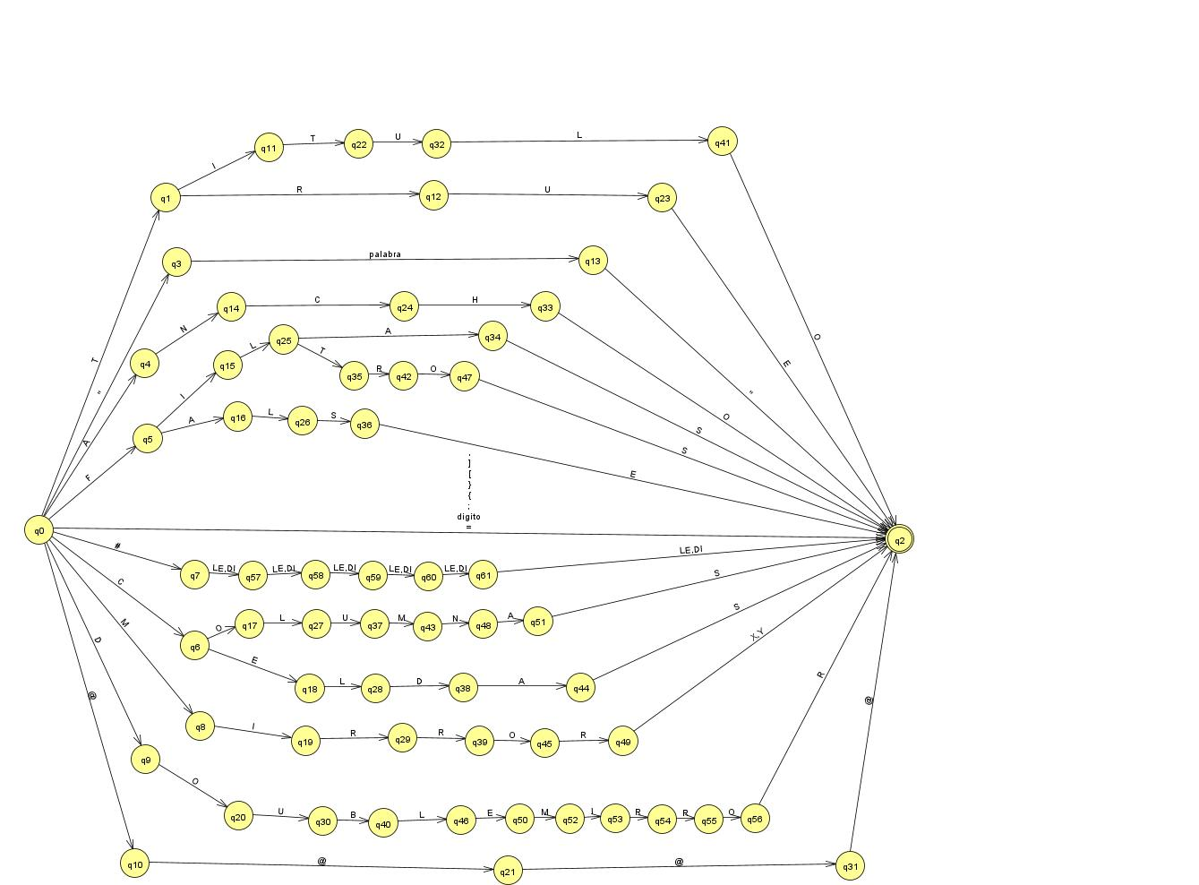Paso 3) Formar el Autómata Finito Determinista (AFD).

*Figura 2. Autómata Finito Determinista (AFD) resultante del método del árbol.*

Fuente: elaboración propia, 2021.